IAM task
1.Create one IAM user and assign EC2 and S3 full access roles.
Go to IAM → Users → Create user
Enter username (example: dev-user)
Click Next
Choose Attach policies directly
Select these two policies:
- AmazonEC2FullAccess
- AmazonS3FullAccess
Click Next → Create user

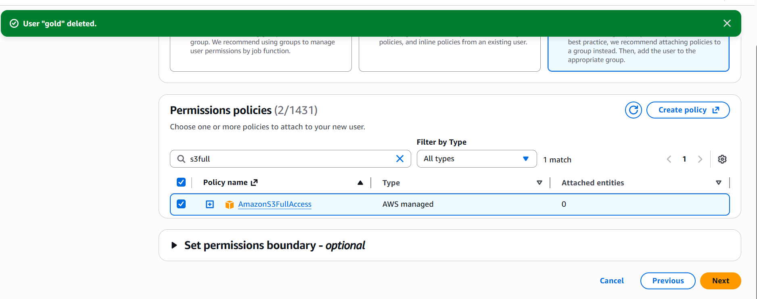
2 .Create one group in IAM and assign read access for EC2.
Go to IAM → User groups → Create group
Enter group name (example: ec2-read-group)
Under permissions, select policy:
- AmazonEC2ReadOnlyAccess
Click Create group
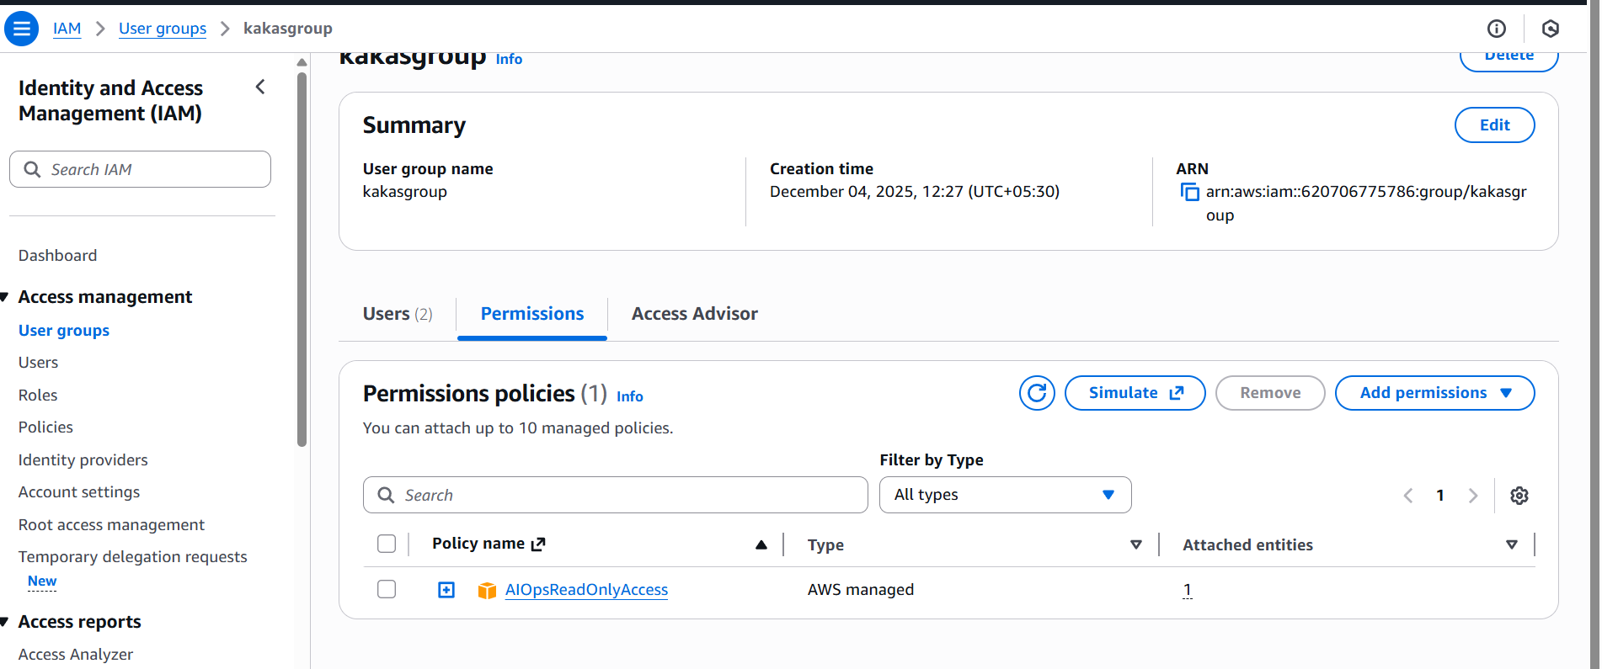

3 . Create a new user named "Devops" and add to the group created in task 2.
Step 1: Open IAM
Go to AWS Console → search IAM.
Step 2: Create User
Click Users.
Click Create user.
Enter username: Devops.
Click Next.
Step 3: Add User to Group
Under Add user to group, select the group you created earlier:
✔ ec2-read-group
Click Next → Create user.

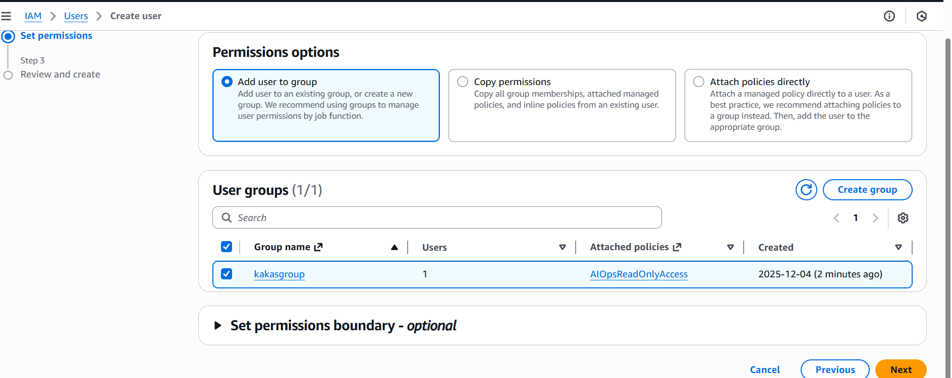
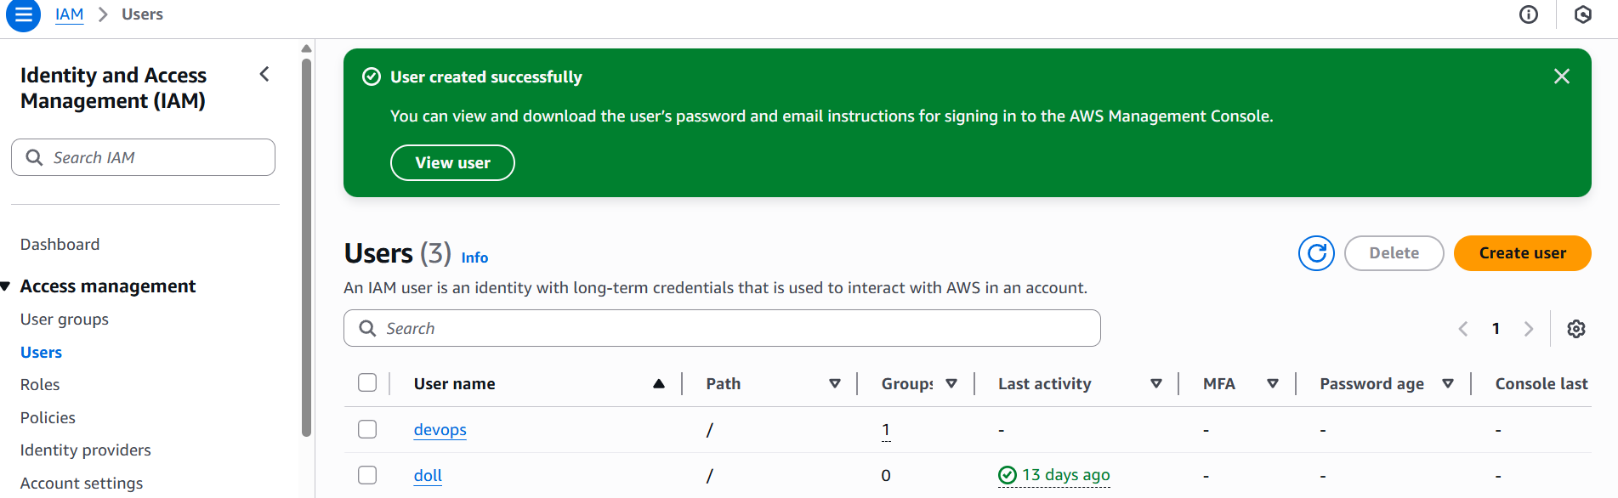

4.Write a bash script to create an IAM user with VPC full access.
Go to Aws console
Connect to the instance by using “ssh”
Generate Access key which will find in security credentials
Aws –version
Aws configure
(details )
Vi create -user.bash
(script paste)
Chmod 755 create-user.bash
./create-user.bash

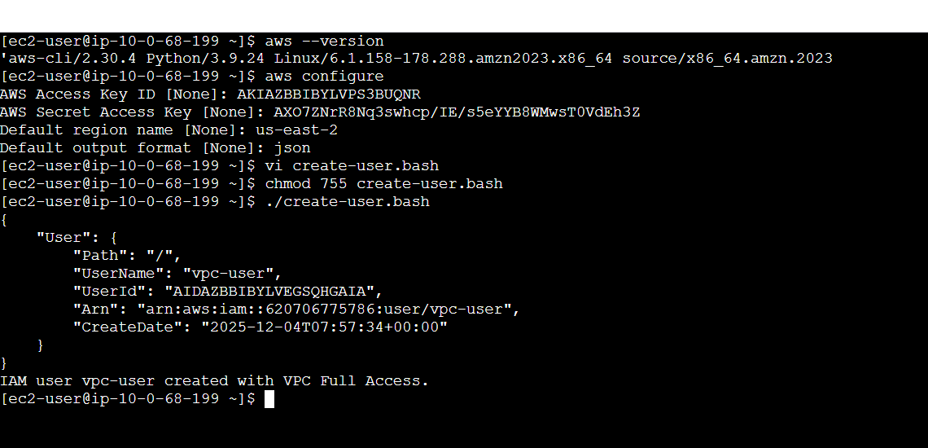

5.Create an IAM policy to allow EC2 access for a specific user in specific regions only.
Step 1: Choose the user
Identify the IAM user who should get EC2 access (example: DevUser).
Step 2: Create a new IAM policy
Go to IAM → Policies → Create Policy
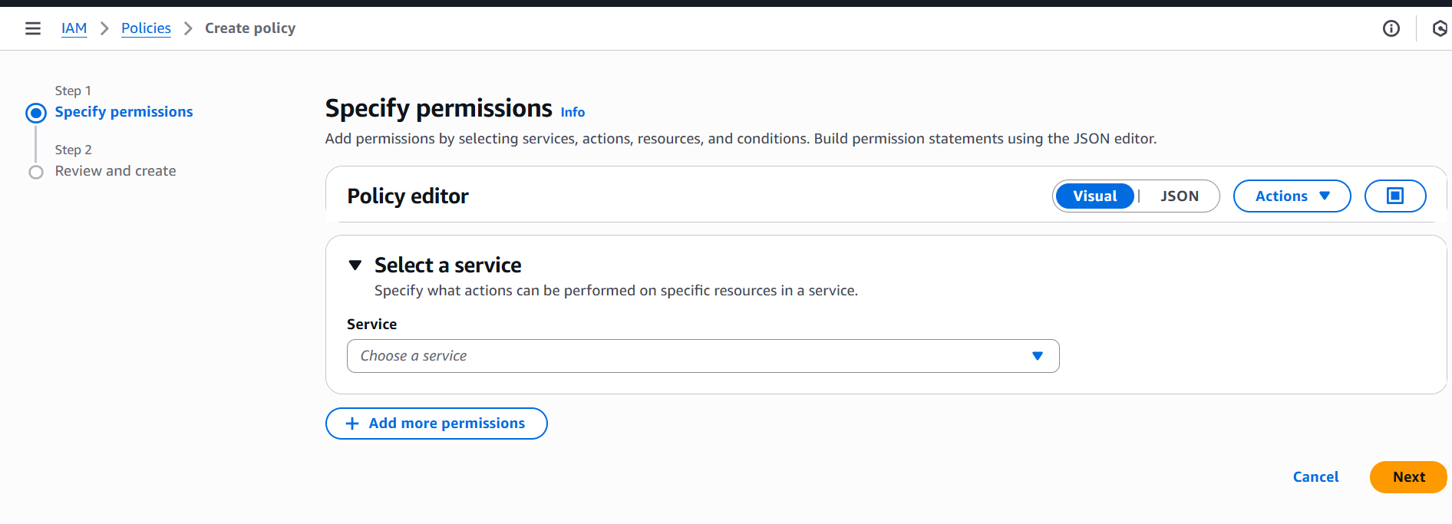

Choose JSON tab
Paste the below policy (modify regions)

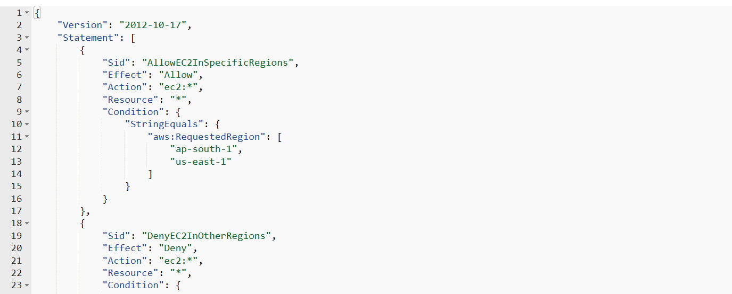

Policies create successfully

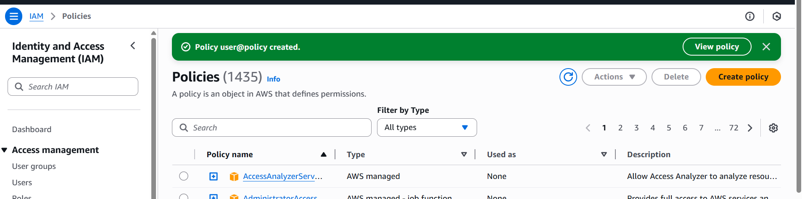

6.We have two accounts: Account A and Account B. Account A user should access an S3 bucket in Account B.
Get the IAM User ARN from Account A
In Account A:
Go to IAM → Users → your user → Copy ARN
Add Bucket Policy in Account B (Grant access to Account A user)
Go to S3 → Bucket → Permissions → Bucket Policy
Replace ACCOUNT_A_ID
Replace USERNAME
Replace bucket name
Attach IAM Policy in Account A to allow S3 actions
